SIMATS ENGINEERING
Department of Computer Science and Engineering
CSA12 — Computer Architecture
Assignment Implementation Report
Design and Analysis of an Energy-Efficient Pipelined Processor
for an Industrial Sensor Monitoring System
Submitted by
Kanishk C
Registration Number: 192511278

Code of Conduct Declaration
I hereby declare that this assignment is my own original work, prepared in accordance with the academic integrity and code of conduct policy of SIMATS Engineering. All sources referred to during preparation have been appropriately acknowledged, and no part of this submission has been copied verbatim from any unacknowledged source.
Academic Year 2026

1. Introduction
Industrial monitoring systems continuously acquire vibration, temperature, pressure, and current signals from field sensors, and must react to abnormal readings within tight, predictable time budgets while operating for years on limited power budgets. This report analyses and designs a small, energy-efficient, pipelined processor suited to this workload. It examines the functional units, instruction execution cycle, addressing modes, and performance metrics of a baseline processor; designs a pipelined datapath and studies its hazards; compares advanced execution techniques (superscalar, out-of-order, speculative, and simultaneous multithreading); designs a hierarchical memory system spanning volatile and non-volatile technologies; recommends and justifies an optimized architecture; maps the design to relevant UN Sustainable Development Goals; and finally presents a Logisim-style schematic and file for a 4-bit pipelined ALU as a concrete illustration of the execute stage.

2. Functional Units of the Processor
A processor for this application is organised into four cooperating functional groups: the CPU core, the memory subsystem, the interconnect (buses), and the I/O/sensor interface, as shown in Figure 1.
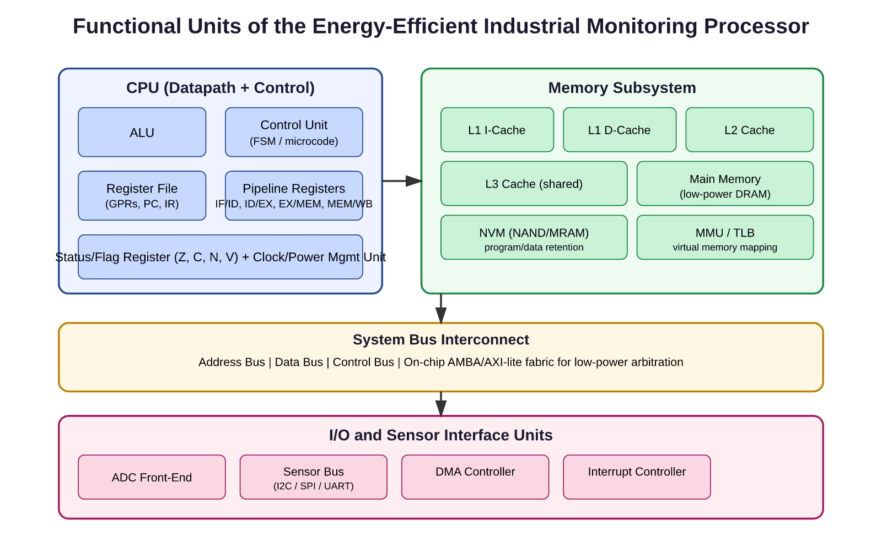
Figure 1: Functional units of the proposed industrial monitoring processor.

2.1 CPU
- Arithmetic Logic Unit (ALU): performs add, subtract, logical, shift and compare operations needed for sensor-value scaling, thresholding and filtering.
- Control Unit (CU): a low-power finite-state machine that generates the sequencing and control signals for fetch, decode and execute, with clock-gating to idle unused stages between sensor samples.
- Register File: general-purpose registers, program counter (PC) and instruction register (IR) for fast operand access without going to memory.
- Pipeline registers and status flags (Zero, Carry, Negative, Overflow) used for condition evaluation and inter-stage data transfer.

2.2 Memory
A small multi-level cache (L1/L2/L3) backed by low-power DRAM and non-volatile memory holds instructions, sensor buffers and calibration constants; Section 9 details this hierarchy.

2.3 Buses
A three-bus structure — address, data and control — connects the CPU, memory and I/O. For this class of processor a lightweight AMBA/AXI-lite-style on-chip fabric is preferred over a wide crossbar because it lowers switching capacitance and hence dynamic power, which matters more than peak bandwidth in a sensor-monitoring workload.

2.4 I/O Components
An ADC front-end digitises analogue sensor signals; a sensor bus (I2C/SPI/UART) connects to distributed transducers; a DMA controller moves sampled data into memory without CPU intervention, letting the core sleep between samples; and an interrupt controller wakes the CPU only when a threshold is crossed or a batch of samples is ready, which is the single largest lever for energy efficiency in this domain.

3. Instruction Execution Cycle and Addressing Modes

3.1 Instruction Execution Cycle
Each instruction passes through the classical fetch-decode-execute cycle: (1) Fetch — the instruction at the address in PC is read from I-cache and PC is incremented; (2) Decode — the opcode and operands are identified and control signals generated; (3) Operand fetch — register or memory operands are read; (4) Execute — the ALU performs the specified operation; (5) Memory access — load/store instructions read or write data memory; (6) Write-back — the result is written to the register file. For a sensor-processing instruction set, this cycle is kept simple and regular (RISC-style, fixed instruction width) so it maps cleanly onto a pipeline (Section 5).

3.2 Addressing Modes
Addressing Mode | Description | Typical Use in this Design
Immediate | Operand is embedded in the instruction. | Loading threshold constants and scaling factors.
Register | Operand is in a CPU register. | Fast arithmetic on live sensor samples.
Direct/Absolute | Instruction holds the full memory address. | Accessing fixed peripheral/ADC registers.
Register Indirect | Register holds the address of the operand. | Walking a circular sensor sample buffer.
Indexed | Base register + offset forms the address. | Accessing array elements in a multi-channel buffer.
Auto-increment/decrement | Register is updated after/before use. | Efficient streaming through DMA sample queues.

Register-indirect and auto-increment modes are especially valuable here because sensor data naturally arrives as streams; they avoid recomputing addresses each cycle and thus save both instruction count and energy.

4. Performance Evaluation
Processor performance is quantified using the standard relation:
Execution Time = Instruction Count × CPI × Clock Cycle Time
where CPI (cycles per instruction) depends on the instruction mix and the fraction of stalls introduced by hazards or cache misses. For an industrial monitoring workload dominated by loads, compares and simple arithmetic, a representative instruction mix and its contribution to CPI is estimated below.
Instruction Class | Frequency | Base Cycles | Contribution to CPI
ALU (add/sub/logic) | 45% | 1 | 0.45
Load/Store | 30% | 2 | 0.60
Branch/Compare | 20% | 1 (predicted) / 3 (mispredicted) | 0.30 (avg., 90% predict rate)
Other (I/O, NOP) | 5% | 1 | 0.05

Summing these contributions gives an effective CPI of approximately 1.4 for the unpipelined baseline. Benchmarking such a design uses representative workload kernels (FIR/IIR filtering, FFT for vibration analysis, threshold comparison loops) rather than generic benchmarks like Dhrystone, since the figure of merit that matters is energy per useful sample processed (measured in nJ/sample) alongside classic MIPS/MFLOPS and cycle counts. Because the target is a battery- or energy-harvesting-powered node, Energy-Delay Product (EDP) is tracked alongside raw execution time so that a faster but disproportionately power-hungry design is not mistaken for an improvement.

5. Pipelined Datapath Design
To raise instruction throughput without raising clock frequency (which would increase dynamic power roughly with the square of supply voltage and linearly with frequency), the datapath is organised into a classic 5-stage pipeline: IF, ID, EX, MEM, WB, separated by pipeline registers that latch each stage's results every clock cycle, as shown in Figure 2.
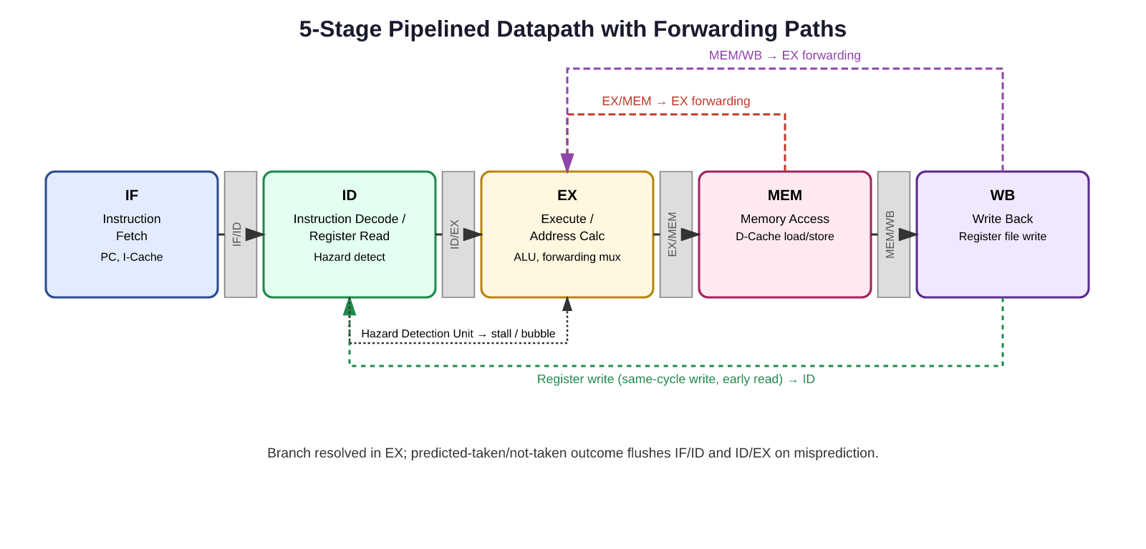
Figure 2: Five-stage pipelined datapath with forwarding paths and hazard-detection unit.
With five instructions in flight simultaneously in the best case, throughput approaches one instruction completed per cycle instead of one every five cycles, a nominal 5× improvement subject to hazards discussed next.

6. Pipeline Hazards
Three classes of hazard limit the ideal throughput of Figure 2:
- Structural hazards — two instructions need the same hardware resource in the same cycle (e.g., a single memory port needed simultaneously by IF and MEM). Resolved by providing separate instruction and data caches/ports.
- Data hazards — an instruction needs a value that a prior, still-in-flight instruction has not yet written back (read-after-write). Resolved by forwarding/bypassing, and by stalling only when forwarding cannot supply the value in time (e.g., immediately after a load).
- Control hazards — the next instruction to fetch is unknown until a branch resolves in EX. Resolved with branch prediction and, on misprediction, a pipeline flush.
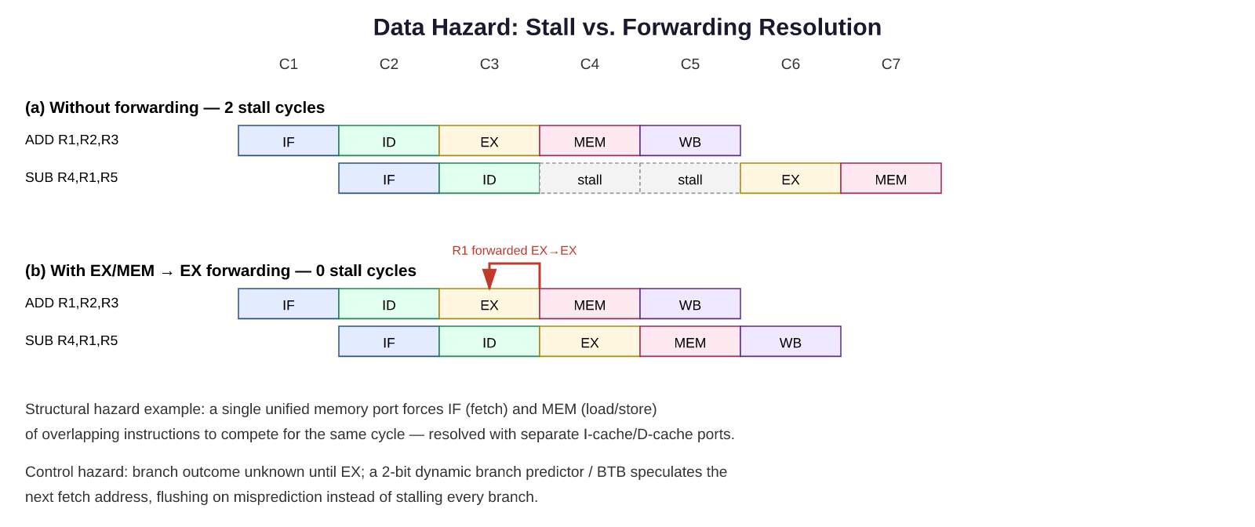
Figure 3: Data hazard timing without forwarding (2-cycle stall) versus with EX/MEM-to-EX forwarding (0-cycle stall).

6.1 Mitigation Techniques
- Forwarding (bypassing): routes the ALU result directly from the EX/MEM or MEM/WB pipeline register back into the EX stage inputs, eliminating most read-after-write stalls.
- Stalling (pipeline interlock): inserted only for load-use hazards that forwarding cannot resolve in time, via a hazard-detection unit that freezes IF/ID and inserts a bubble.
- Branch prediction: a 2-bit saturating-counter dynamic predictor with a small branch-target buffer (BTB) predicts branch direction/target so the pipeline continues speculatively; a misprediction flushes the 1-2 fetched instructions and restarts, which is far cheaper on average than stalling every branch.
For this workload, threshold-comparison branches are frequent but highly biased (the sensor is normal far more often than it is anomalous), so even a simple 2-bit predictor achieves high accuracy (~90%+), making the average control-hazard penalty small.

7. Superscalar, Out-of-Order, and Speculative Execution
Technique | Core Idea | Benefit | Cost / Suitability Here
Superscalar | Fetch/decode/execute multiple instructions per cycle using duplicated pipeline stages/functional units. | Raises peak IPC above 1 without raising clock frequency. | Extra decode/issue logic and register ports raise area and static power; sensor workloads have limited instruction-level parallelism (ILP), so gains are modest relative to cost.
Out-of-order execution | Instructions execute as operands become ready (Tomasulo/scoreboarding), not in program order, with in-order commit. | Hides latency (e.g., cache misses) by executing independent later instructions. | Requires reorder buffers, reservation stations and register renaming — substantial area/power overhead for a workload that is mostly memory- and control-bound rather than ILP-bound.
Speculative execution | Predicts branch outcomes (or values) and executes tentatively, squashing on misprediction. | Keeps a deep or wide pipeline fed despite control hazards. | Complements simple branch prediction; deep speculation depth is not justified here since the code has few, well-predicted branches.

For an energy-constrained monitoring processor, the marginal IPC gained from full superscalar/out-of-order hardware rarely justifies its static-power and verification cost; a modestly dual-issue, in-order pipeline with good forwarding and simple branch prediction captures most of the achievable benefit at a fraction of the power.

8. Simultaneous Multithreading (SMT) Suitability
SMT lets a single pipeline interleave instructions from multiple hardware threads each cycle, filling issue slots left empty by one thread's stalls (e.g., a cache miss) with useful work from another. This is attractive when a processor must service several independent sensor channels or run a lightweight monitoring task alongside a communication/protocol task, since one thread's memory-wait bubbles can be filled by another thread's ALU work, improving functional-unit utilisation without duplicating the whole pipeline.
However, SMT duplicates architectural state (register files, PC) and adds thread-selection logic, increasing both area and leakage power, and its benefit shrinks if only one sensor channel is typically active. For a small industrial node with two or three loosely-coupled tasks (acquisition, filtering, communication), a lightweight 2-way SMT is a reasonable middle ground; for a single-channel, mostly-idle sensor node, plain single-threaded execution with aggressive clock-gating is more energy-efficient than SMT.

9. Hierarchical Memory System
Figure 4 shows the proposed memory hierarchy, sized for an embedded monitoring core rather than a general-purpose CPU.
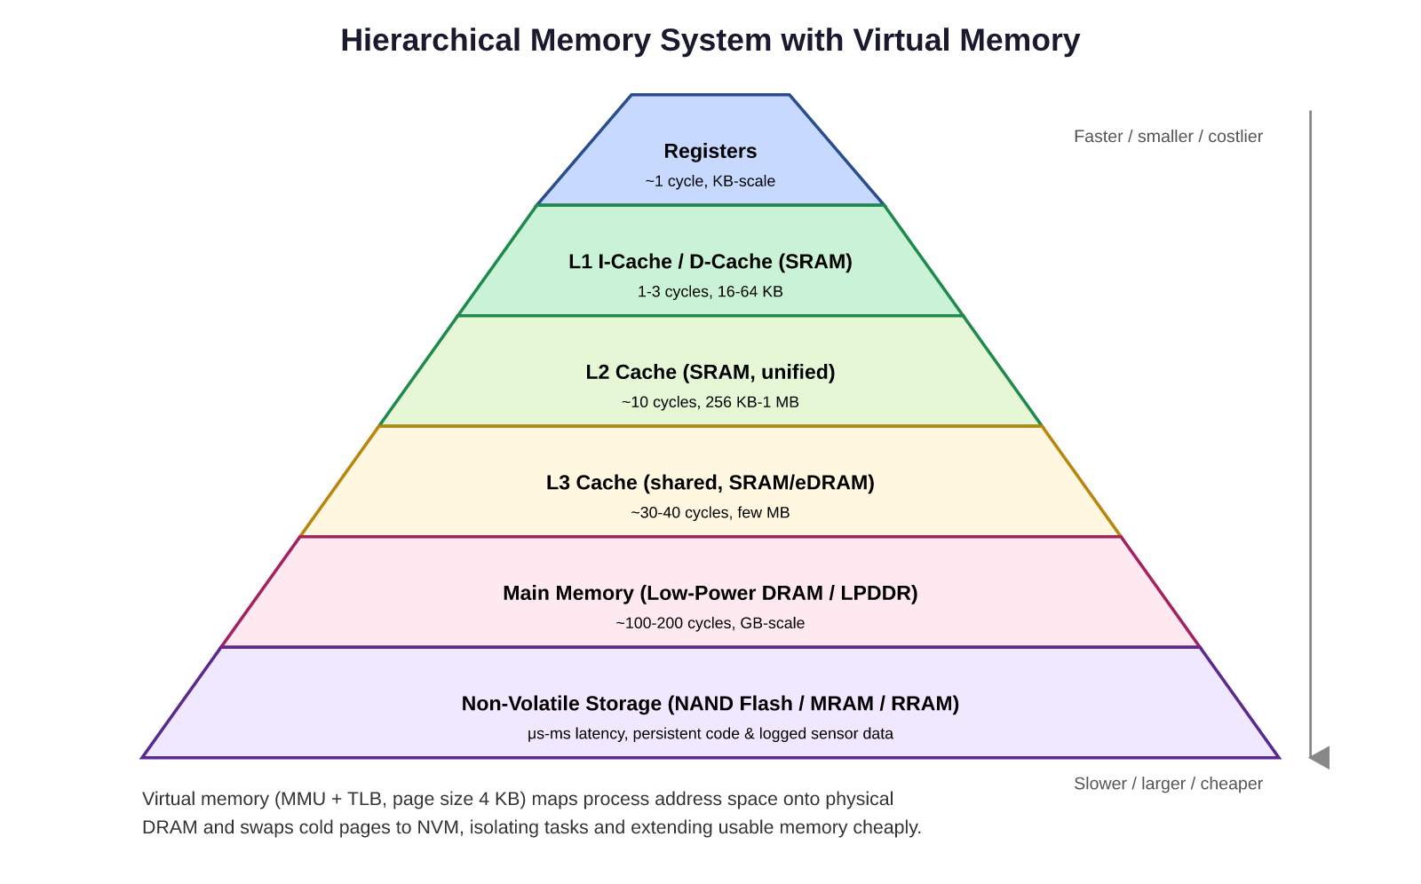
Figure 4: Hierarchical cache/memory organisation with virtual memory support.
Small, split L1 instruction and data caches (16-32 KB, 1-3 cycle latency) serve the common case; a unified L2 (256 KB-1 MB) captures the working set of filtering/FFT kernels; an optional shared L3 helps only if multiple cores/threads are present. A small MMU with a TLB provides virtual memory: it isolates the acquisition, control and communication tasks from one another, allows a simple paged view of a larger non-volatile store, and can map rarely used code pages to slower NVM to save DRAM refresh power. Because footprints in this domain are small and predictable, a simple two-level TLB and modest page table are sufficient — a full desktop-class virtual memory system would add unnecessary power and complexity.

10. Comparison of Memory Technologies
Technology | Latency | Bandwidth | Throughput | Power | Volatility
SRAM | Very low (~1 ns) | Very high | High (used for L1-L3) | Low dynamic, moderate static (leakage) | Volatile
DRAM | Low-moderate (~10-60 ns) | High | High, needs refresh overhead | Moderate (refresh + access) | Volatile
NAND Flash | High (μs-ms, esp. writes/erase) | Moderate | Low for random writes | Low idle, higher for program/erase | Non-volatile
MRAM | Low (~10-30 ns), near-DRAM | Moderate-high | Good for read/write balance | Low, no refresh needed | Non-volatile
RRAM | Low-moderate (~10-50 ns) | Moderate | Good, still maturing | Very low, no refresh | Non-volatile

SRAM remains the only realistic choice for L1-L3 caches because of its speed. DRAM is retained for main memory but its periodic refresh is a significant, workload-independent energy drain that is undesirable for a duty-cycled sensor node. Emerging non-volatile memories (MRAM, RRAM) are attractive complements: they approach DRAM-like latency without refresh energy and retain data without power, which is valuable for storing calibration data and logged events through power interruptions; NAND Flash remains the cost-effective choice for bulk, infrequently written data logging.

11. Recommended Processor and Memory Organisation
- Core: a single-issue, in-order 5-stage pipeline (Section 5) with full forwarding and a 2-bit dynamic branch predictor — sufficient ILP capture for this workload at low control complexity.
- Optional light dual-issue superscalar front end only if multiple sensor channels must be serviced concurrently; otherwise avoided to save area/leakage power.
- 2-way SMT considered only when acquisition, filtering and communication tasks genuinely run concurrently; disabled (power-gated) when the node is single-channel or idle.
- Memory: split L1 I/D caches (16-32 KB) in SRAM, a small unified L2 (256 KB) in SRAM, low-power (LPDDR-class) DRAM for main memory, and an MRAM or NAND block for non-volatile program storage and event logging, tied together by a simple MMU/TLB for task isolation.
- Aggressive clock-gating and power-gating of unused pipeline stages, caches, and the ALU between sensor samples, driven by the interrupt controller and DMA rather than active polling.

12. Justification of the Proposed Design
Performance: the pipeline yields close to 5× the instruction throughput of a non-pipelined design for a small area cost, and forwarding plus simple branch prediction recover most of the throughput lost to hazards, keeping effective CPI close to 1 for this instruction mix (Section 4).
Power: avoiding full superscalar/out-of-order/wide-SMT hardware removes the largest sources of static (leakage) power and verification cost, which dominate over dynamic switching power once duty-cycling is applied; replacing part of main memory with non-volatile MRAM/RRAM removes DRAM refresh energy during long idle intervals typical of environmental/industrial monitoring.
Resource utilisation: the cache hierarchy is sized to the workload's real footprint (small filtering kernels and circular sample buffers) rather than over-provisioned as in general-purpose CPUs, so silicon area and static power are spent where they earn their keep — this matches the design philosophy of application-specific, energy-proportional embedded processors.

13. Alignment with UN Sustainable Development Goals

SDG 7 — Affordable and Clean Energy
Aggressive clock/power gating, a right-sized in-order pipeline, and refresh-free non-volatile memory sharply cut the processor's energy draw, letting the monitoring node run for years on a small battery or on harvested energy (solar/vibration), directly supporting clean, low-consumption energy use at the edge.

SDG 9 — Industry, Innovation and Infrastructure
The design demonstrates an application-specific approach to processor and memory-hierarchy co-design (pipelining, hazard mitigation, emerging non-volatile memory) that strengthens resilient, efficient industrial infrastructure and encourages innovation in domain-specific computing for factories and utilities.

SDG 12 — Responsible Consumption and Production
By continuously monitoring machinery for early signs of wear or anomalous behaviour, the processor enables predictive maintenance that reduces material waste, prevents catastrophic failures, and extends equipment lifetime — while its own energy-proportional design minimises the resources consumed by the monitoring infrastructure itself.

14. 4-bit Pipelined ALU — Logisim Design
As a concrete, buildable illustration of the EX-stage hardware discussed in Section 5, a 4-bit ALU with a two-stage internal pipeline (an input-latch stage that registers operands A, B and the opcode, and an output-latch stage that registers the ALU result, carry-out and zero flag) is designed. Figure 5 shows a Logisim-style schematic of this circuit, and an accompanying Logisim project file (.circ) implementing the same design is provided alongside this report.
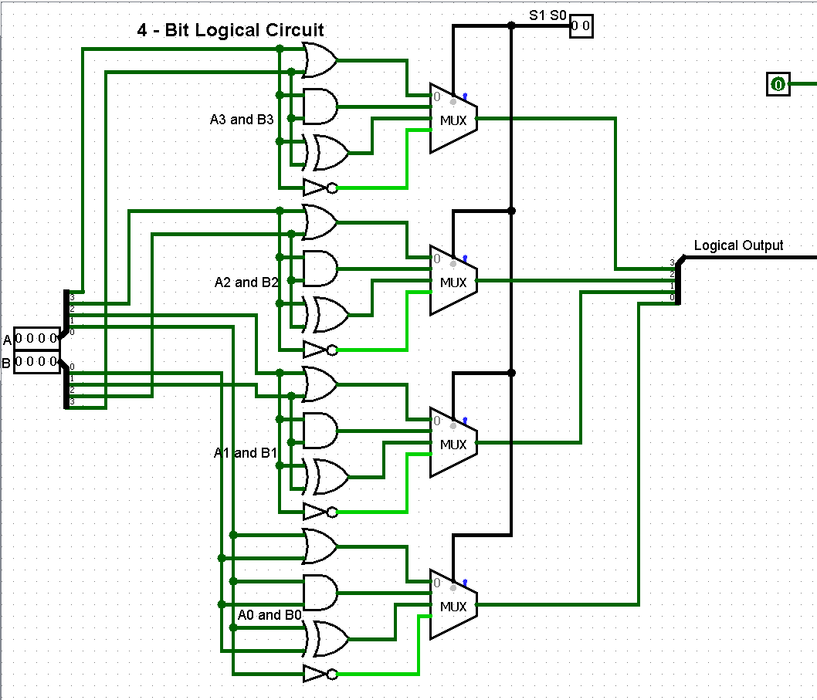
Figure 5: 4-bit pipelined ALU schematic (Logisim style) — Stage 1 latches operands/opcode; Stage 2 computes and latches Result, Cout and Zero.
Operation: on each rising clock edge, Stage 1 captures new A, B and Op values into RegA/RegB/RegOp while Stage 2 simultaneously latches whatever result the ALU computed from the previous cycle's operands into RegResult/RegCout/RegZero. This overlap means a new operand pair can be accepted every cycle even though the ALU's combinational delay spans a full stage, exactly mirroring the EX-stage pipelining principle from Section 5 at a small, hand-traceable scale. The provided file 4bit_pipelined_ALU.circ can be opened directly in Logisim (Logisim-evolution) to simulate and step through this behaviour.

15. Conclusion
A carefully scoped, single-issue 5-stage pipeline with full forwarding, simple dynamic branch prediction, a right-sized SRAM/DRAM/NVM memory hierarchy, and selective use of SMT only where genuine task-level concurrency exists, offers the best balance of throughput, power and area for an industrial sensor-monitoring processor. Full superscalar, out-of-order and wide-SMT techniques are available as scaling options but are not justified by this workload's limited instruction-level parallelism, and would work against the energy-efficiency goals central to SDG 7, SDG 9 and SDG 12. The accompanying 4-bit pipelined ALU design demonstrates the same pipelining principle in a small, verifiable circuit.

